Screenshots: Ethical Hacking and VAPT
Step 1: Set up the bee-box

Step 2: Scan the bee-box for vulnerability
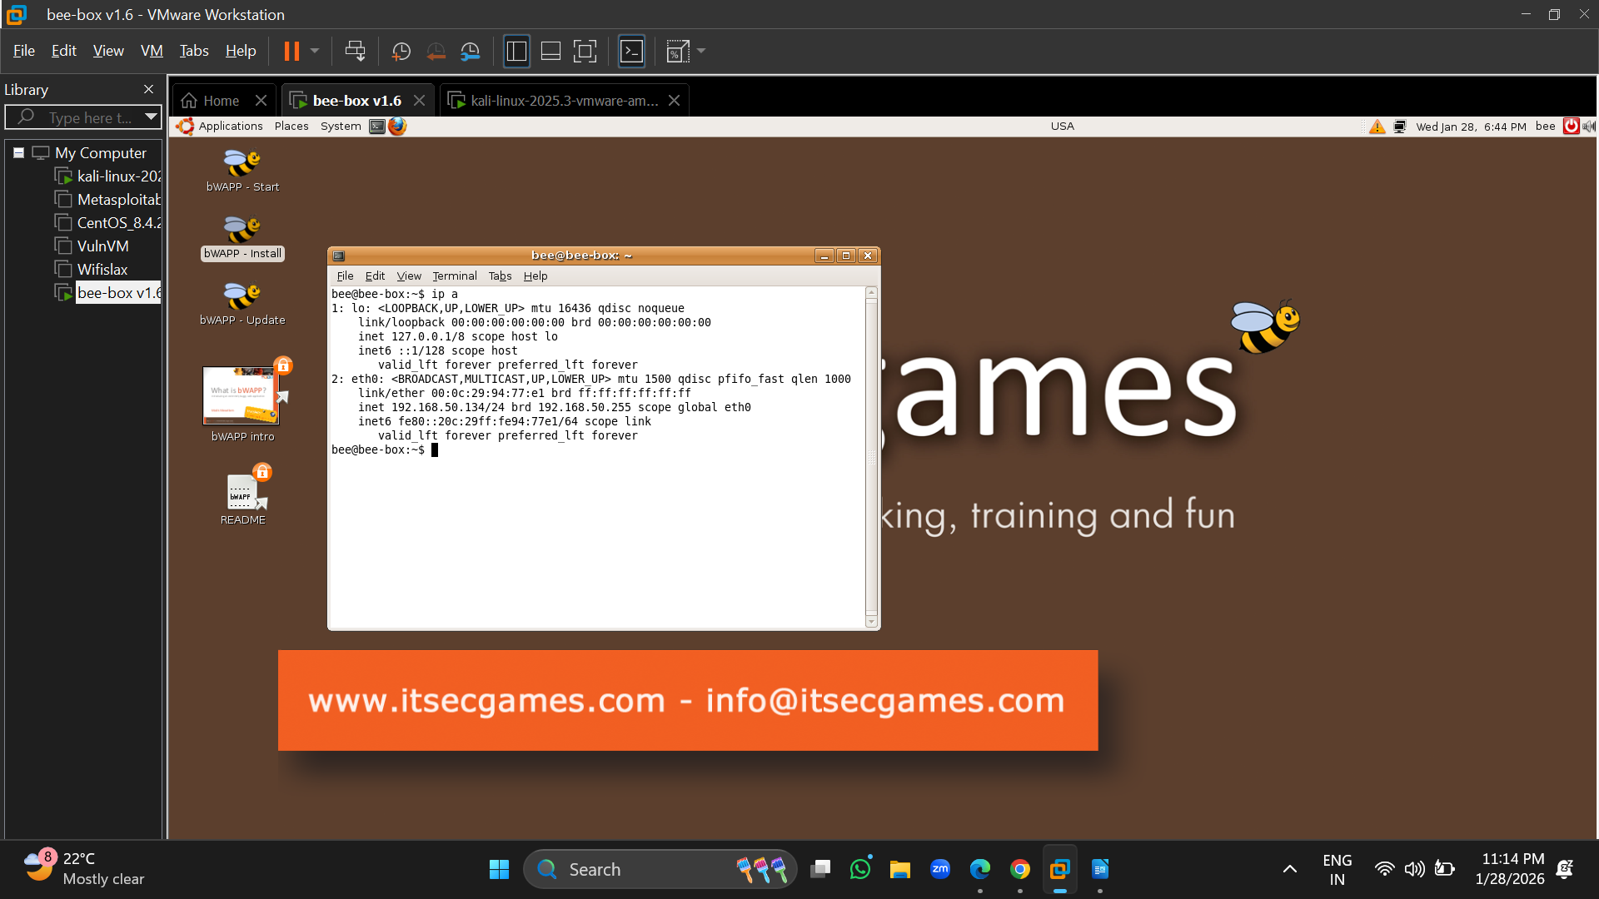
Step 3: Exploit the SNMP using Metasploit

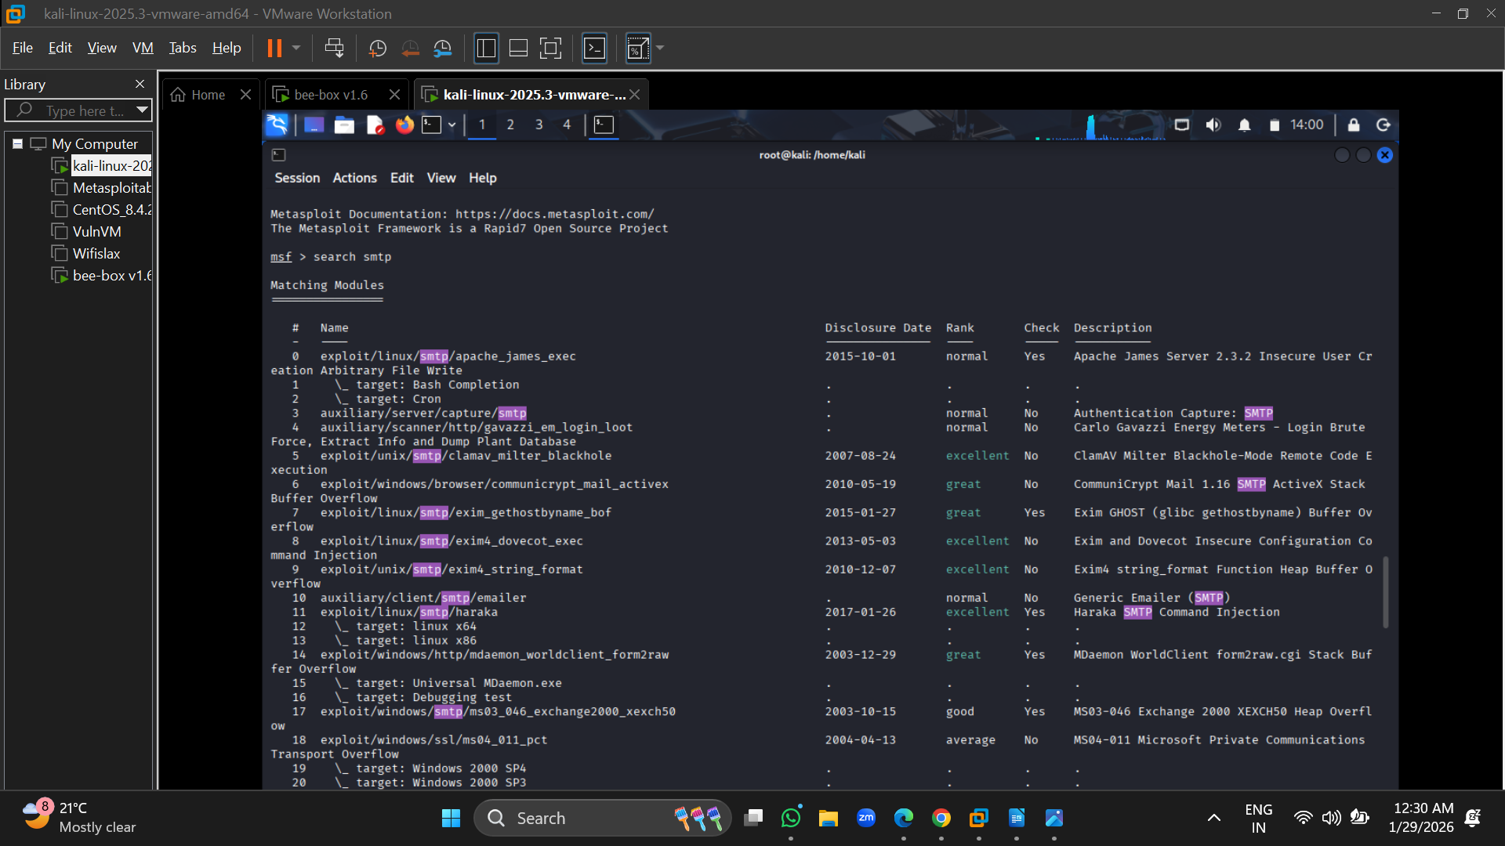
Step 4: Login anonymously with ftp
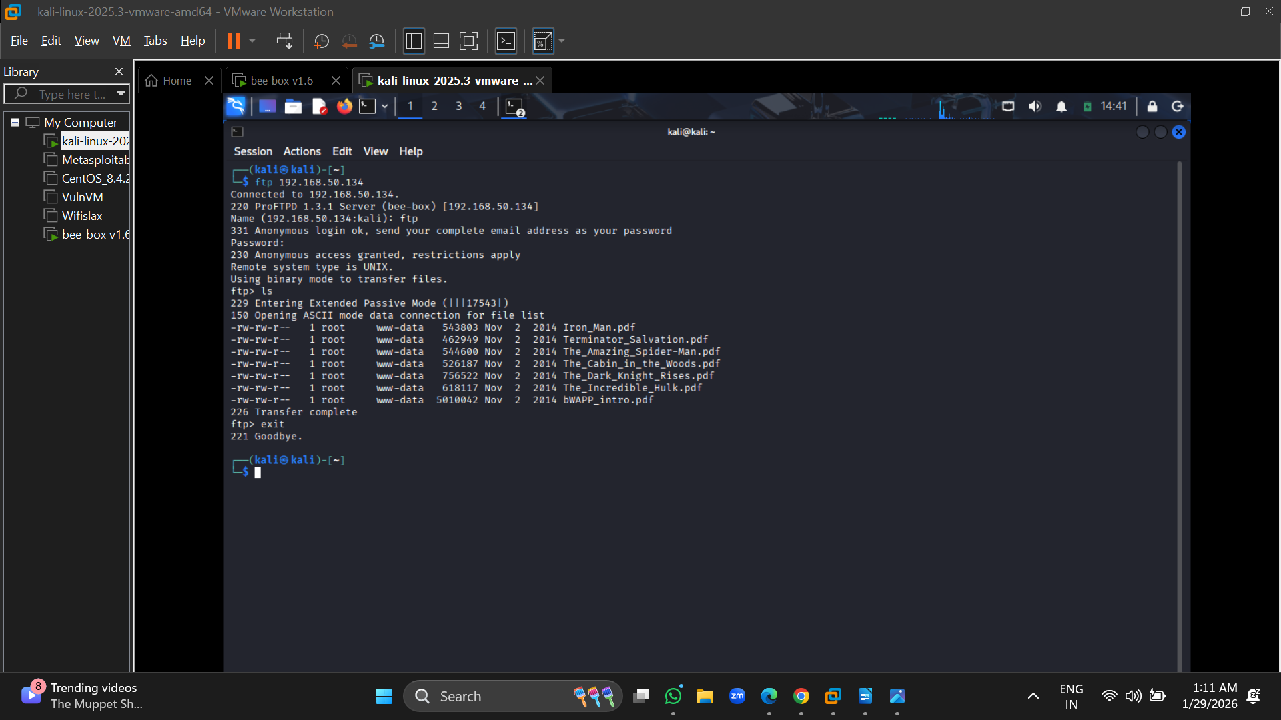
Step 5: Deny the anonymous login

